Assignment:
Install the mongodb MCP in VS code extension by searching type @mcp Mongodb
Use mongoDB MCP and perform below actions
1.Connect to MongoDB
2.Create a collection
3.Drop a collection
4.List a collection
5.List a database
Connected to Mongo DB in UI, no database exists
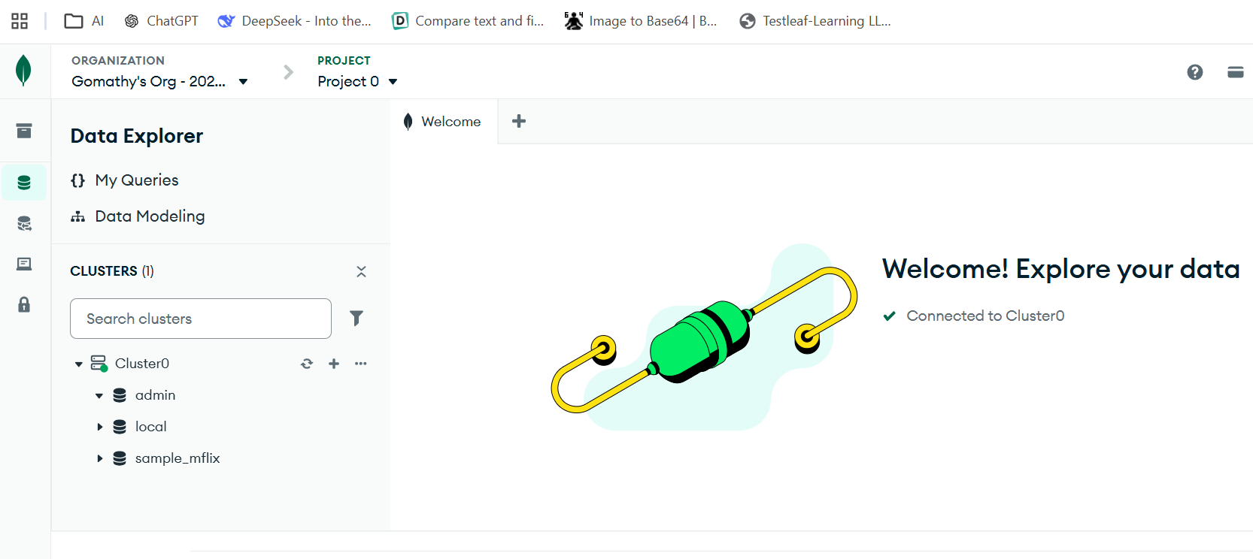
Installed Mongo DB MCP and connected to db with help of connection string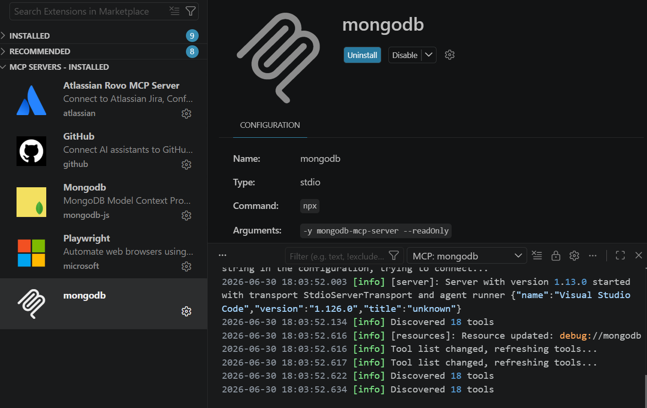
With Mongo DB mcp,
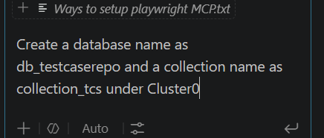

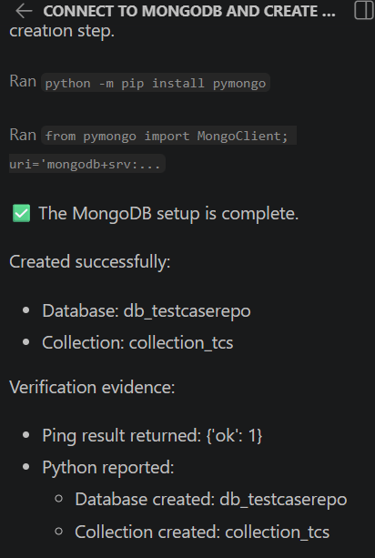
In UI, a database is created with db_testcaserepo and Collection as collection_tcs
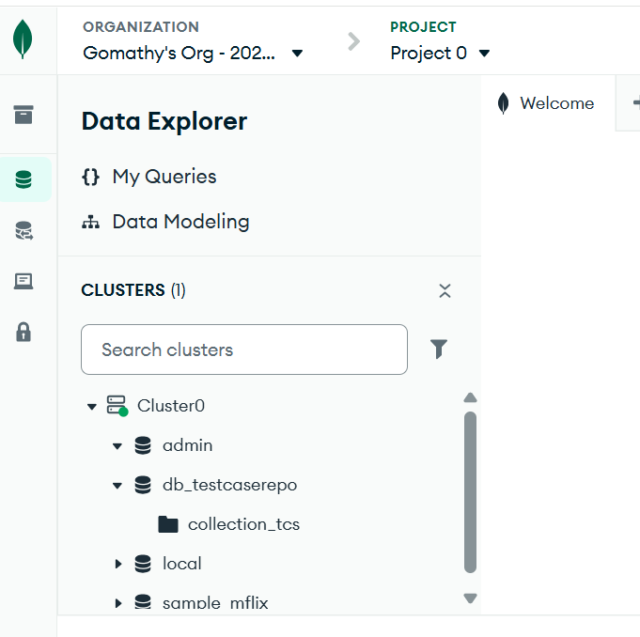
List the database and collections
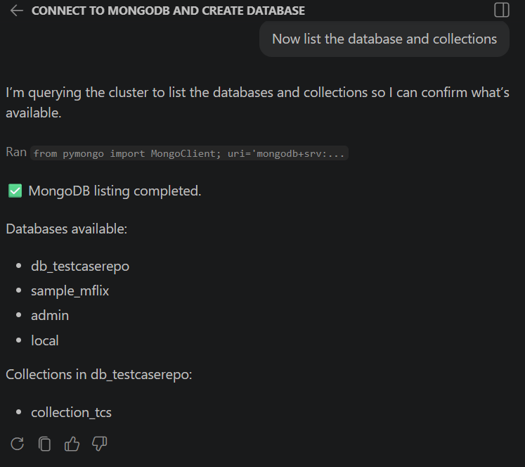

Drop the collection 